SHEEP Enrollment tutorial

- First go to

www.SHEEP.education
Click on enroll
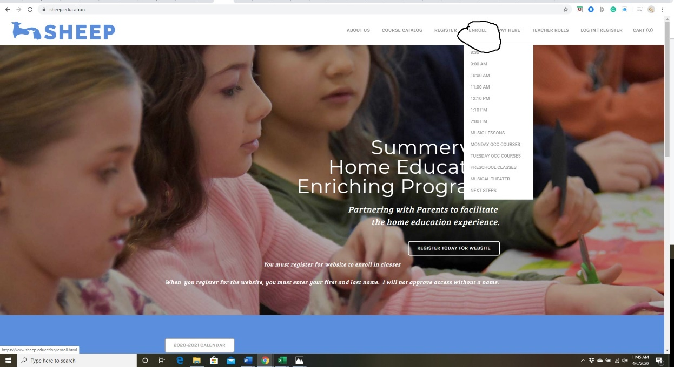

- You will get tis page
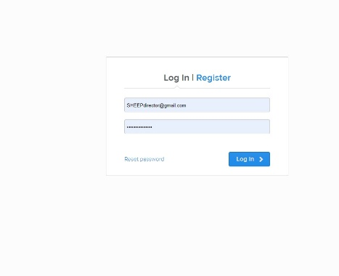
If you get “access denied” or other problem, email me immediately. Email me at director@sheep.education. If all opens up, you are doing great!

- Choose you class. Click on class you want from that hour.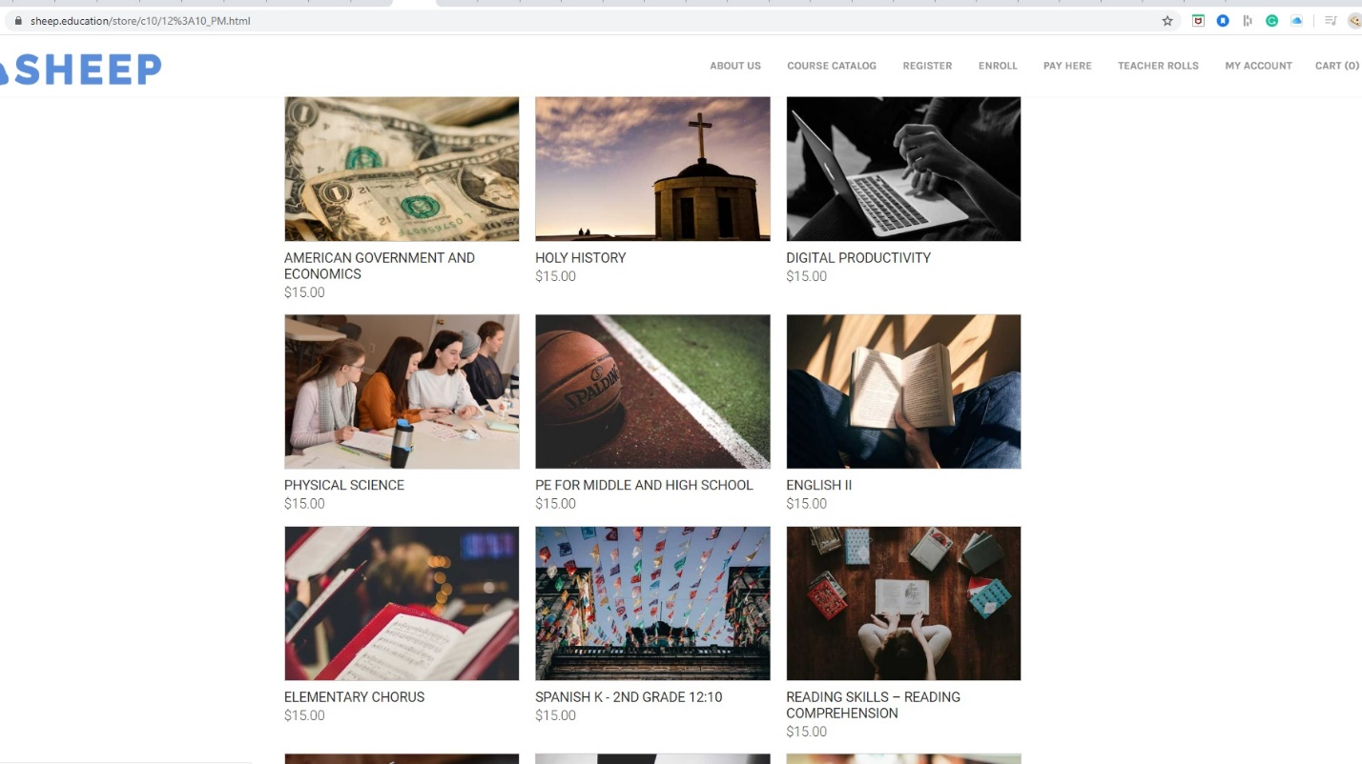
- Fill out info for that class. Don’t skip any lines
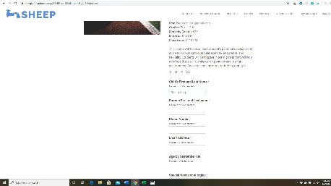

- Click add to cart. Repeat step 3 and 4 for each class that you want. Remember to always add to your cart
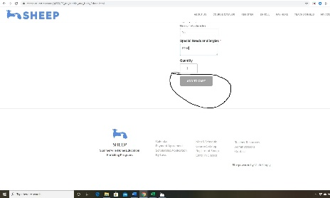

- When you have finished choosing all of your classes click on the cart in the right-hand top of the page.
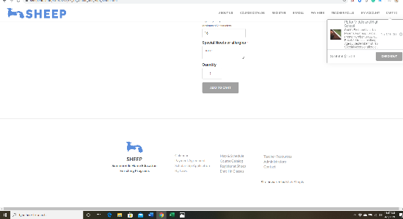

- After you click on cart, you will click Check Out
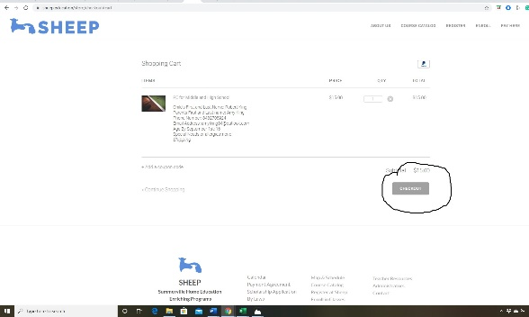

- Fill out all information in Secure Check out
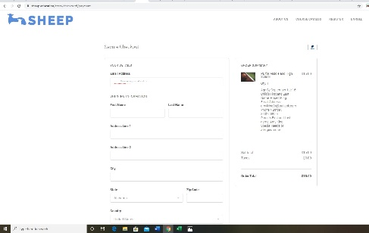

- After you fill out click NEXT at the bottom of the page
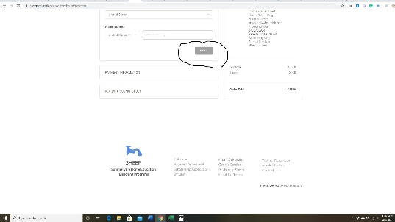

- You will be taken to Paypal. Fill out appropriate information
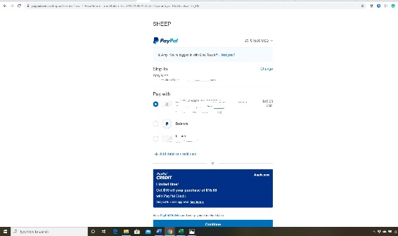

- Click COMPLETE ORDER
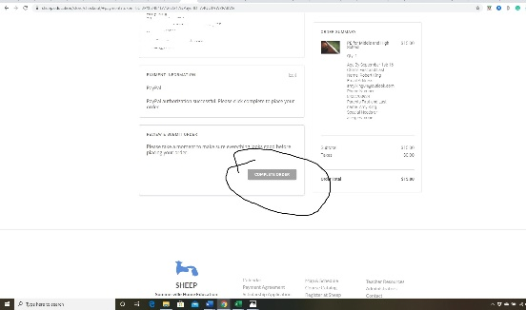

- Come to the confirmation page. If you see this page you have successfully enrolled in all your classes. Occasionally you will get to check out and something you put in your basket will not be in your order. That is because someone checkout with the last item before you. If this happens let me know and I will put you on a waiting list. Sometimes I can add more people to a class. Make sure you see this page
